Active/Passive fire protection systems

Active measures - involved the control of smoke spread, detection and communication process that informs the occurrence of a fire outbreak and triggers some sort of counteraction towards design and in addition augment the active measures. It is a proactive approach extinguishing the fire.

Passive measures - more concerned with building structures integrity, compartmentation and the integrity of the building envelope.

Passive Fire Protection is an all encompassing fire safety concept which embraces the passive measures in fire containment taken at the building design stage, aimed at addressing a comprehensive solution to the fire problem".

Active Fire Protection
Modern buildings built under the strict design and buildings codes of today have many fire protection systems installed by default. These systems assist with detection and response to fire related emergencies.
If you have questions or maintenance issues in regards to any of this equipment, please contact the Property and Campus Services - Maintenance Department on (03) 8344 6000.

Fire Break Glass Alarm (B.G.A.)
Buildings fitted with a "Fire - Break Glass Alarm" allow occupants to activate the fire alarm and alert the fire brigade easily. The red panel on the wall houses a small button that when depressed will contact the Fire Brigade. The Fire Brigade will respond instantly to the building. You should always try to ring University Security on x46666 to confirm the fire.
The glass, or perspex material is easy to break with your fist, elbow or a pen. Smashing the glass will sometimes activate the button automatically.

Fire Control Systems
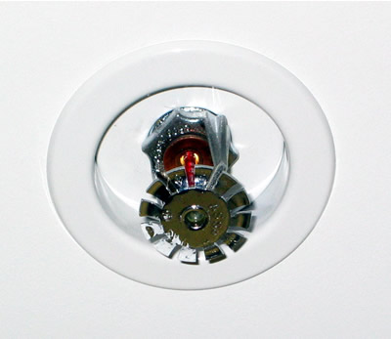
Some buildings or sections of buildings are fitted with automatically activated sprinkler heads. On activation, the sprinklers discharge a fine mist of water to extinguish/contain a fire.
In other special risk locations such as flammable liquids storerooms, computer rooms (main frames), flood systems are used to extinguish fire. Where gaseous flooding systems are installed in normally occupied areas (e.g. computer rooms), a warning alarm is sounded prior to the discharge of gas into the room. A warning notice instructing personnel what to do should also be displayed.

Fire Indicator Panel (F.I.P.)
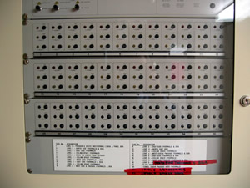
The F.I.P. is the hub of the fire alarm system in a building. It is usually located on the ground floor near an entrance close to the nearest road. The panel may be located in a cabinet or on a wall. On the panel is a number of lights and buttons. These lights "indicate" which fire sensor has activated in the building.
The F.I.P. will automatically notify the fire brigade of an alarm when one of its sensors locates a fire. The F.I.P. will usually talk to the E.W.I.S. (where installed) and notify the building occupants that they need to evacuate.

Fire Doors
Fire doors are installed to minimise the spread of fire, including the passage of smoke through a building.
Fire doors may be automatically operated by heat activated mechanisms or smoke detectors. The securing of fire doors must be such that persons leaving an area via the fire door can do so without the use of keys or similar at all times. Fire doors must not be wedged open.

Smoke and Thermal Fire Detectors
The detection system in buildings may sense either heat or smoke or a combination of these. Smoke detectors are increasingly being used because of their earlier warning of an emergency situation. Smoke detectors may also be used to activate fire doors to isolate zones in the building.

Portable Fire Extinguishers
Portable fire fighting equipment such as fire extinguishers are designed to provide the user with an appliance to attend a small fire during its initial stage.

Fire Hose Reels & Fire Hydrants
Canvas fire hoses attached to or adjacent to fire hydrant points are installed only for use by the Fire Brigade. They must not be used by untrained personnel

http://www.pb.unimelb.edu.au/emergency/emergencies/fire/firesystems.html

Passive Fire Protection
There are many passive fire protection systems available to reduce the rise in temperature of steel members when exposed to elevated temperatures in a fire situation. Buchanan, (2001), states that fire resistance rating of a protected steel member although determined by calculations and depends on factors such as properties of protection material and fire temperature, there has to be some assurance of the fire resistance rating. This usually is achieved by full-scale testing of the structural system incorporating fire protection material, thus validating the effectiveness of the protection material used for specified fire duration in a real fire situation.
Protection systems commonly used to increase the fire resistance rating of steel members are listed below and briefly explained (Buchanan, 2001).
a) Concrete encasement,
b) Board systems,
c) Spray- on systems,
d) Intumescent paints,
e) Timber encasing,
f) Concrete filling,
g) Water filling, and
h) Flame shields.
Concrete encasement involves pouring of concrete in the formwork housing the steel members. Reinforcement is provided to hold concrete in place during a fire situation and the required thickness of the concrete is determined from the design codes. A certain disadvantage of this form of protection is that it results in increased construction costs and bulky structural members.
Board systems are mainly developed using calcium silicate or gypsum plaster. Calcium silicate boards are made of an inert material that is designed to remain in place during the duration of the fire. Gypsum boards have good insulating properties as well, and its resistance in fire is enhanced by the presence of water in the board which vaporise in elevated temperatures. This reaction provides a time delay when the board reaches about 100 °C, but reduces the strength of the board after exposure to fire. Advantages of this form of protection system are that it is easy installation and finishing enhancing the aesthetic aspects of design.
Spray-on protection system is usually the cheapest form of fire protection for steel members. Materials used for this method usually are cement-based with some form of glass or cellulosic fibrous reinforcing to hold the material together. The disadvantage of this method is that the application is a wet and messy one and the finished work is not aesthetically attractive. This form of fire protection is usually applied to beams rather than columns because it can be easily damaged due to soft material composition. Structural components such as bolts, steel brackets are likely to be protected with the spray-on protection system because other forms of protection might be difficult.
Intumescent paint is a special paint that swells into a thick char when it is exposed to elevated temperatures enhancing the fire rating of the steel member beneath. The advantage of this protecting system is that the application is a quick process, is less bulky and the member can be simply painted over thus not deteriorating the appearance of the steelwork. The disadvantage being that it is more expensive than other systems such as board and spray-on systems.
Using timber boards to encase structural members is another method of fire protecting system. The timber used has to be well seasoned and a thermosetting adhesive are usually used to firmly fix the boarding over the structural members.
Concrete filling is mainly used for hollow steel sections to improve their fire performance. An advantage of the system is that external protection is not required and can increase the load bearing capacity of that member. The infill concrete can be reinforced or be in the form of plain concrete.
Water filling system works in a similar principle to concrete filling where hollow steel sections are filled with water. The in filled water has some additives added in order to prevent corrosion. This form of protection requires plumbing systems to ensure water will flow in the members by convection and excessive pressure is not developed by heated water. It is only used in special structures and is considered expensive when compared with other systems.
Flame shields are used to protect external structural steelwork from radiation by flames exiting through the window openings. Usually architectural claddings are installed to form the shields

http://eprints.usq.edu.au/archive/00002230/01/GOUNDER_Sanjeevam-2005.pdf.pdf

AUSTRALIAN STANDARD - AS 1530.4
SECTION 1. SCOPE AND GENERAL
SECTION 2. GENERAL REQUIREMENTS
SECTION 3. WALLS AND PARTITIONS
SECTION 4. FLOORS, ROOFS, FLOOR/CEILING SYSTEMS ANDROOF/CEILING SYSTEMS
SECTION 5. COLUMNS
SECTION 6 BEAMS, GIRDERS AND TRUSSES
SECTION 7. DOORSETS, SHUTTER ASSEMBLIES AND DAMPER
ASSEMBLIES
SECTION 8. GLAZING
SECTION 9. AIR DUCTS
SECTION 10. ELEMENTS PENETRATED BY SERVICES

APPENDIX A. RADIANT HEAT FLUX MEASUREMENTS

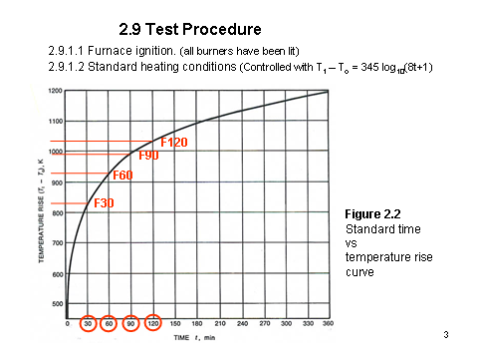

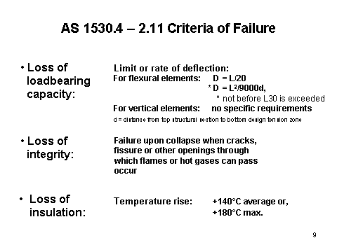

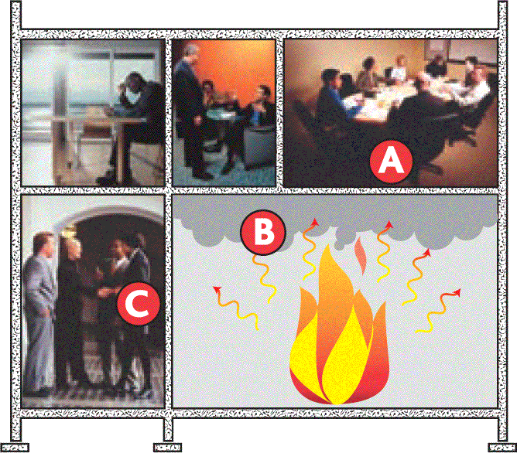
Fire Limit States

A: The structure should retain its loadbearing capacity.

B: The structure should protect people from harmful smoke and gases.

C: The structure should shield people from heat.

PART C2 COMPARTMENTATION AND SEPARATION
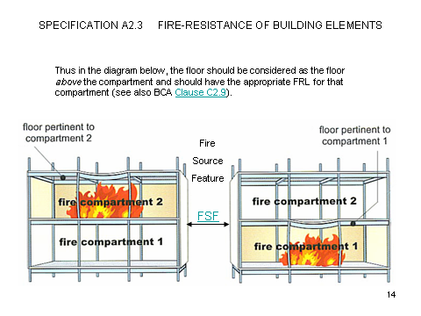
Passive fire protection deals with the design of a building for adequate load bearing resistance and for limiting fire spread under fire conditions. Structural Fire Engineering is generally categorized in this discipline.
Fire Protection Engineering
Fire Protection Engineering comprises active and passive ways of providing satisfactory protection level to buildings and/or its contents from fires.
Sound design for guaranteeing fire safety of buildings
Design Specifications
• Layout of the facility
• Construction materials
• Potential ventilation openings
• Interconnections among compartments
• Location of concealed spaces
• Proposed egress routes
• Anticipated fuel load (type & quantity)
• Functions in the building
• Passive fire protection systems
• Active fire protection systems
• Occupant load and characteristics

Failure Criteria for Compartmentation
AS 1530.4 – 2.11 Criteria of Failure
Compartment Failure or Failure of the Enclosure??
• Criteria for compartment failure or structural failure as
given in Standardised test requirements provide a
means of ranking the performance of materials and
products under a specific set of conditions.
• The objective of defining a compartment is to prevent
fire spread. In dealing with real fires in real buildings we
should therefore dispense with the traditional approach of
defining a compartment but quantify the ability of fire to
spread from an enclosure.

Building Code of Australia
PART C1 FIRE RESISTANCE AND STABILITY
Fire resistant Construction
Type A
Type B
Type C

C1.1 Type of construction required
The minimum Type of fire-resisting construction of a building must be that specified in Table C1.1 and Specification C1.1, except as allowed for—
(i) certain Class 2, 3 or 9c buildings in C1.5; and
(ii) * * * * *
(iii) open spectator stands and indoor sports stadiums in C1.7.
(iv) * * * * *
Type A construction is the most fire-resistant and Type C the least fire-resistant of the Types of construction.
Rise in storeys | Class of building
Rise in storeys | 2, 3, 9 | 5, 6, 7, 8
4 OR MORE | A | A
3 | A | B
2 | B | C
1 | C | C

Table C1.1 TYPE OF CONSTRUCTION REQUIRED

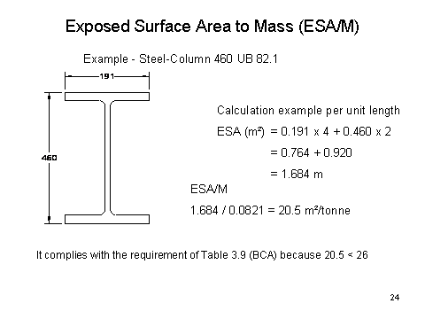
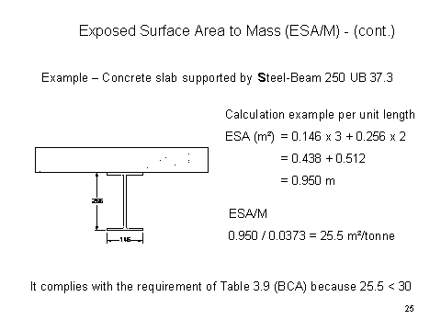

3. TYPE A FIRE-RESISTING CONSTRUCTION
BCA extract

3 TYPE a FIRE-RESISTING CONSTRUCTION
Fire-resistance of building elements. In a building required to be of Type A construction—
(a) each building element listed in Table 3 and any beam or column incorporated in it, must have an FRL not less than that listed in the Table for the particular Class of building concerned; and
(b) external walls, common walls and the flooring and floor framing of lift pits must be non-combustible; and
(c) any internal wall required to have an FRL with respect to integrity and insulation must extend to—
(i) the underside of the floor next above; or
(ii) the underside of a roof complying with Table 3; or
(iii) if under Clause 3.5 the roof is not required to comply with Table 3, the underside of the non-combustible roof covering and, except for roof battens with dimensions of 75 mm x 50 mm or less or roof sarking, must not be crossed by timber or other combustible building elements; or
(iv) a ceiling that is immediately below the roof and has a resistance to the incipient spread of fire to the roof space between the ceiling and the roof of not less than 60 minutes; and
(d) a load bearing internal wall and a load bearing fire wall (including those that are part of a load bearing shaft) must be of concrete or masonry; and
(e) a non- load bearing—
(i) internal wall required to be fire-resisting; and
(ii) lift, ventilating, pipe, garbage, or similar shaft that is not for the discharge of hot products of combustion, must be of non-combustible construction; and
(f) the FRLs specified in Table 3 for an external column apply also to those parts of an internal column that face and are within 1.5 m of a window and are exposed through that window to a fire-source feature.Table 3.9 Requirements for carparks

4. TYPE B FIRE-RESISTING CONSTRUCTION
Fire- resistance of building elementsIn a building required to be of Type B construction—
(a) each building element listed in Table 4, and any beam or column incorporated in it, must have an FRL not less than that listed in the Table for the particular Class of building concerned; and
(b) the external walls, common walls, and the flooring and floor framing in any lift pit, must be non-combustible; and
(c) if a stair shaft supports any floor or a structural part of it—and
(d) any internal wall which is required to have an FRL with respect to integrity and insulation, except a wall that bounds a sole-occupancy unit in the topmost (or only) storey and there is only one unit in that storey, must extend to— and
(e) a loadbearing internal wall and a loadbearing fire wall (including those that are part of a loadbearing shaft) must be of concrete or masonry; and
a non- loadbearing internal wall required to be fire-resisting must be of non-combustible construction; and
(f) in a Class 5, 6, 7, 8 or 9 building, in the storey immediately below the roof, internal columns and internal walls other than fire walls and shaft walls, need not comply with Table 4; and
lift, subject to C2.10, ventilating, pipe, garbage, and similar shafts which are not for the discharge of hot products of combustion and not loadbearing, must be of non-combustible construction in—and
(g) in a Class 2 or 3 building, except where within the one sole-occupancy unit, or a Class 9a health-care building or a Class 9b building, a floor separating storeys or above a space for the accommodation of motor vehicles or used for storage or any other ancillary purpose

SPECIFICATION C1.1 FIRE-RESISTING CONSTRUCTION
GENERAL REQUIREMENTS
2.1 Exposure to fire-source features
(a) A part of a building element is exposed to a fire-source feature if any of the horizontal s traight lines between that part and the fire-source feature, or vertical projection of the feature, is not obstructed by another part of the building that—
(i) has an FRL of not less than 30/–/–; and
(ii) is neither transparent nor translucent.
(b) A part of a building element is not exposed to a fire-source feature if the fire-source feature is—
(i) an external wall of another building that stands on the allotment and the part concerned is more than 15 m above the highest part of thatexternal wall; or
(ii) a side or rear boundary of the allotment and the part concerned is below the level of the finished ground at every relevant part of the boundary concerned.
(c) If various distances apply for different parts of a building element—
(i) the entire element must have the FRL applicable to that part having the least distance between itself and the relevant fire-source feature; or
(ii) each part of the element must have the FRL applicable according to its individual distance from the relevant fire-source feature,
but this provision does not override or permit any exemption from Clause 2.2.
Fire protection for a support of another part
(a) Where a part of a building required to have an FRL depends upon direct vertical or lateral support from another part to maintain its FRL, that supporting part, subject to (b), must—
(i) have an FRL not less than that required by other provisions of this Specification; and
(ii) if located within the same fire compartment as the part it supports have an FRL in respect of structural adequacy the greater of that required—
(A) for the supporting part itself; and
(B) for the part it supports; and
(iii) be non-combustible—
(A)if required by other provisions of this Specification; or
(B)if the part it supports is required to be non-combustible.
(b) The following building elements need not comply with (a)(ii) and (a)(iii)(B):
(i) An element providing lateral support to an external wall complying with Clause 5.1(b) or C1.11.
(ii) An element providing support within a carpark and complying with Clause 3.9, 4.2 (iii) A roof providing lateral support in a building—
(A)of Type A construction if it complies with Clause 3.5(a), (b) or (d); and
(B)of Type B and C construction.
(iv) A column providing lateral support to a wall where the column complies with Clause 2.5(a) and (b).
(v) An element providing lateral support to a fire wall or fire-resisting wall, provided the wall is supported on both sides and failure of the element on one side does not affect the fire performance of the wall.

Vertical and lateral support
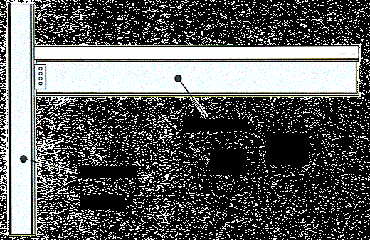
Beam
Column
Column provides
vertical support
to beam
Beam provides
lateral support
to column

Fire behaviour of steel members penetrating concrete walls
The measurement of heat release rate (HRR) and smoke production rate (SPR) are direct indicators of the fire hazard. The growth of the HRR enables a lining material to be classified with respect to time based on if or when flashover occurs. The measurements of gas species, percentage of flame spread area over the lining surface, and compartment temperatures and smoke layer height, are compared to confirm that the conditions generated are consistent with the primary parameters of HRR and SPR and accurately reflect the fire hazard

3.5 Roof: Concession

A roof need not comply with Table 3 if its covering is non-combustible and the building—
(a) has a sprinkler system complying with Specification E1.5 installed throughout; or
(b) has a rise in storeys of 3 or less; or
(c) is of Class 2 or 3; or
(d) has an effective height of not more than 25 m and the ceiling immediately below the roof has a resistance to the incipient spread of fire to the roof space of not less than 60 minutes.

Key Factors for Time-Equivalent Analysis
When a fire reaches a stage where there is full involvement of the combustibles within a compartment (known as flashover), the intensity of the heat in the hot smoke layer will cause glazing and non-fire resisting facades to fail, allowing hot gases to escape (see Figure below).

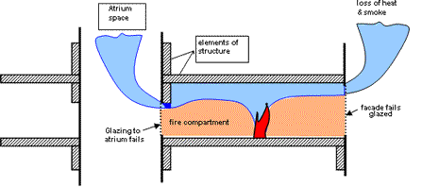
Similarly, openings to atria will also allow hot gases to escape. The temperatures reached in a compartment and the duration of a fire depend on natural ventilation through openings to atria and glazing or non-fire resisting facades that fail in a fire.

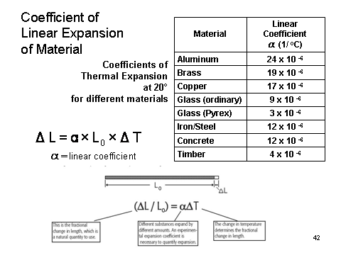

Mechanism of Fire Spread
• Conduction
(Heat transfer to another body or within a body by direct contact.)
• Radiation
(Heat transfer by way of electromagnetic energy.)
• Convection
(Heat transfer by circulation within a medium, such as a gas or a liquid.)
• Pyrolysis
(The transformation of a compound into one or more other substances by heat alone. Pyrolysis often precedes combustion. Irreversible chemical decomposition caused by heat, usually without combustion.)
• Mass transfer

• In a fire engineering approach the conditions for failure and its consequences should be set in a qualitative design review for the particular building or structure concerned.
• Some of these may be more or less onerous than the traditional specifications given in Standardised test methods but should be prescribed to suit the particular circumstances and their potential impact on the overall safety of the building and its occupants.
• All enclosures can initially be considered as a compartment until one of the conditions for fire spread has been achieved.
Methods of Direct Fire Spread

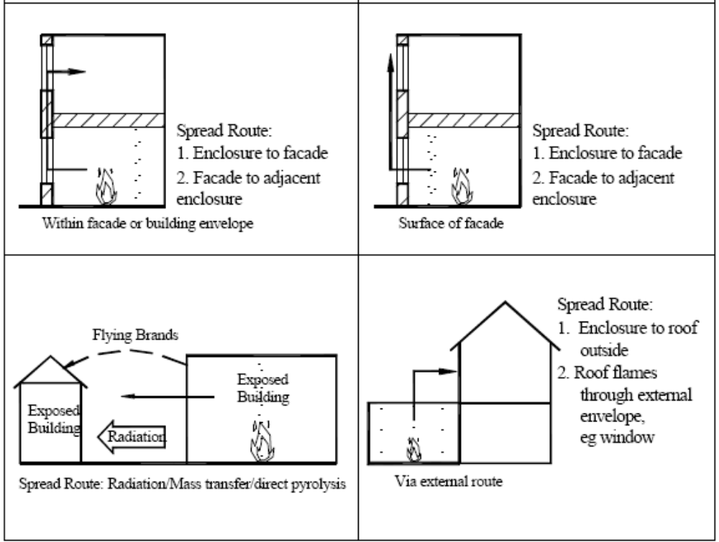

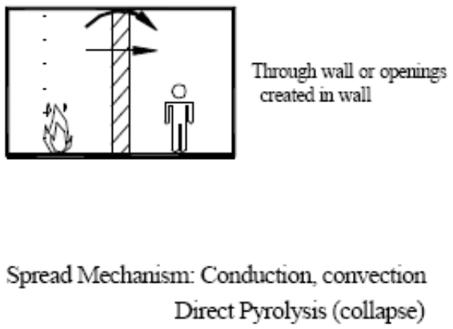
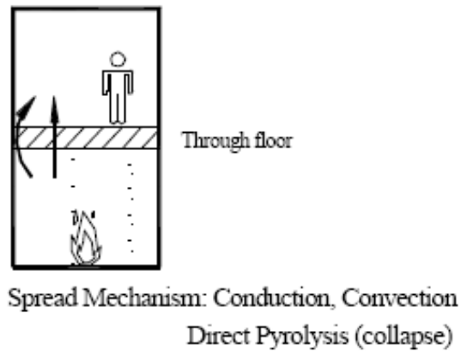

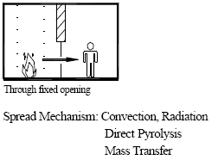
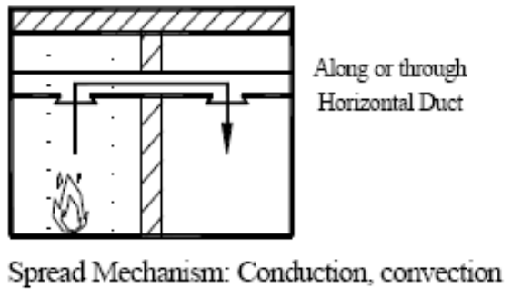

A simply supported beam will fail as soon as one plastic hinge forms in the beam.
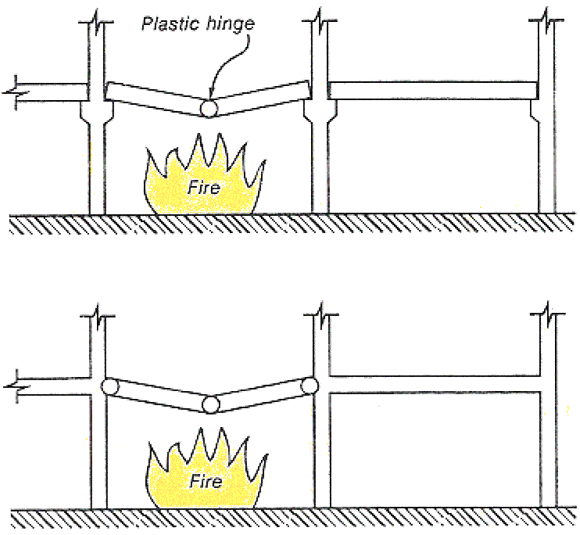

At this point the flexural capacity of the beam is same as the applied moments.

